Gap Analysis:
Preventing Violence, Harassment and Bullying Against Health Workers Second Edition Work Sheet

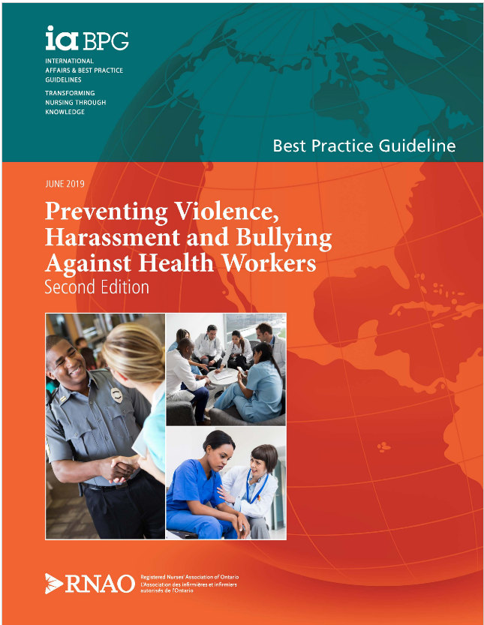

This guideline can be downloaded for free at:
https://rnao.ca/bpg/guidelines/preventing-violence-harassment-and-bullying-against-health-workers

The RNAO Leading Change Toolkit 3rd Edition
https://rnao.ca/leading-change-toolkit

Date Completed:
Team Members participating in the Gap Analysis:

Completion of this gap analysis allows for the annual comparison of your current practice to evidence-based practices as regulated by the MOHLTC per Fixing Long-Term Care Act, 2021 at https://www.ontario.ca/laws/statute/21f39 & O. Reg. 246/22: GENERAL (ontario.ca) also Occupational Health and Safety Act, R.S.O. 1990, c. O.1 (ontario.ca)
RNAO Best Practice Guideline Recommendations | Met | Partially Met | Unmet | Notes  (Examples of what to include: is this a priority to our home, information on current practice, possible overlap with other programs or partners)
Recommendations addressing violent behaviour from persons
1.0 - Assessment
1.1: The expert panel recommends that health service organizations establish an implementation plan for integrating a violence risk assessment tool for persons. This plan should include the following:
- selection of a risk assessment tool that is applicable to the clinical population and setting; and
- education and training on the chosen tool for all health workers who provide direct care.
(Level of Evidence = Strong)
1.2: The expert panel recommends that health workers conduct a violence risk assessment on all persons using a validated tool.
(Level of Evidence = Strong)
2.0 - Organizational Policies and Procedures
2.1: The expert panel recommends that health service organizations provide education and training to health workers on addressing violent behaviours from persons (see Recommendations 3.1 to 3.3 for specific education content).
(Level of Evidence = Strong)
2.2: The expert panel recommends that health service organizations implement protective and security measures, such as the following:
- documentation and communication of a person’s previous incident(s) of violence;
- equipment to protect against violent behaviours, and a standardized approach for deciding what, when, and how to use these;
- environmental security measures, including locked doors, closed-circuit cameras and alarm systems; and
- formal reporting systems that are simple to use.
(Level of Evidence = Strong)
2.3: The expert panel recommends that formal leaders within health service organizations support health workers in preventing and addressing workplace violence by doing the following:
- understanding and implementing policies against workplace violence; and
- reviewing and acting on reported workplace violence incidents.
(Level of Evidence = Strong)
2.4: The expert panel recommends that health service organizations implement a process for formal incident reviews immediately following a violent event to discuss the details of what occurred, the approach that was used, and the strategies for violence prevention in the future.
(Level of Evidence = Strong)
3.0 - Education and Workplace Training
3.1: The expert panel recommends that health service organizations provide education to health workers on the risk factors and triggers for violent behaviours from persons.
(Level of Evidence = Strong)
3.2: The expert panel recommends that health service organizations provide training to health workers on de-escalation techniques, including communication and re-direction strategies, to prevent and/or reduce violent incidents within their organizations.
(Level of Evidence = Strong)
3.3: The expert panel recommends that health workers are provided training in breakaway techniques and when to safely use breakaway techniques in violent incidents
(Level of Evidence = Strong)
Recommendation addressing harassment and bullying from formal leaders, other health workers, or students
1.0 - Assessment
1.3: The expert panel suggests that health service organizations and academic institutions support the use of validated risk assessment tools to measure and develop a quality improvement plan to address horizontal and/or vertical violence.
(Level of Evidence = Conditional)
2.0 - Organizational Policies and Procedures

2.5: The expert panel suggests that health service organizations and academic institutions provide education and training to health workers and students on addressing workplace harassment and bullying (see Recommendations 3.4 and 3.5 for specific education content).
(Level of Evidence = Conditional)
2.6: The expert panel recommends that health service organizations and academic institutions implement appropriate policies and codes of conduct to address harassment and bullying in the workplace and learning environment.
(Level of Evidence = Strong)
2.7: The expert panel recommends that formal leaders in health service organizations and academic institutions be actively involved in preventing and addressing harassment and bullying to support health workers and students by doing the following:
- understanding and reinforcing policies that address harassment and bullying; and
- providing mentorship and role modelling of professional behaviour.
(Level of Evidence = Strong)
3.0 - Education and Workplace Training
3.4: The expert panel suggests that health service organizations provide education to health workers on how to identify harassment and bullying, understand the impact of harassment and bullying, and use effective communication strategies.
(Level of Evidence = Conditional)
3.5: The expert panel recommends that, as part of an interactive learning approach, students learn to use guided communication responses to address harassment and bullying from multiple sources within an academic institution or clinical learning environment.
(Level of Evidence = Strong)

Appendix A
Applicable Ministry of Labour legislation - Occupational Health and Safety Act R.S.O. 1990, CHAPTER O.1

PART III.0.1 VIOLENCE AND HARASSMENT
Policies, violence and harassment
32.0.1 (1) An employer shall,
(a) prepare a policy with respect to workplace violence;
(b) prepare a policy with respect to workplace harassment; and
(c) review the policies as often as is necessary, but at least annually. 2009, c. 23, s. 3.

Written form, posting
(2) The policies shall be in written form and shall be posted at a conspicuous place in the workplace. 2009, c. 23, s. 3.

Exception
(3) Subsection (2) does not apply if the number of workers regularly employed at the workplace is five or fewer, unless an inspector orders otherwise. 2009, c. 23, s. 3; 2011, c. 1, Sched. 7, s. 2 (3).
Program, violence
32.0.2 (1) An employer shall develop and maintain a program to implement the policy with respect to workplace violence required under clause 32.0.1 (1) (a). 2009, c. 23, s. 3.

Contents
(2) Without limiting the generality of subsection (1), the program shall,
(a) include measures and procedures to control the risks identified in the assessment required under subsection 32.0.3 (1) as likely to expose a worker to physical injury;
(b) include measures and procedures for summoning immediate assistance when workplace violence occurs or is likely to occur;
(c) include measures and procedures for workers to report incidents of workplace violence to the employer or supervisor;
(d) set out how the employer will investigate and deal with incidents or complaints of workplace violence; and
(e) include any prescribed elements. 2009, c. 23, s. 3.
Assessment of risks of violence
32.0.3 (1) An employer shall assess the risks of workplace violence that may arise from the nature of the workplace, the type of work or the conditions of work. 2009, c. 23, s. 3.

Considerations
(2) The assessment shall take into account,
(a) circumstances that would be common to similar workplaces;
(b) circumstances specific to the workplace; and
(c) any other prescribed elements. 2009, c. 23, s. 3.

Results
(3) An employer shall,
(a) advise the committee or a health and safety representative, if any, of the results of the assessment, and provide a copy if the assessment is in writing; and
(b) if there is no committee or health and safety representative, advise the workers of the results of the assessment and, if the assessment is in writing, provide copies on request or advise the workers how to obtain copies. 2009, c. 23, s. 3.

Reassessment
(4) An employer shall reassess the risks of workplace violence as often as is necessary to ensure that the related policy under clause 32.0.1 (1) (a) and the related program under subsection 32.0.2 (1) continue to protect workers from workplace violence. 2009, c. 23, s. 3.

Same
(5) Subsection (3) also applies with respect to the results of the reassessment. 2009, c. 23, s. 3.
Domestic violence
32.0.4 If an employer becomes aware, or ought reasonably to be aware, that domestic violence that would likely expose a worker to physical injury may occur in the workplace, the employer shall take every precaution reasonable in the circumstances for the protection of the worker. 2009, c. 23, s. 3.
Duties re violence
32.0.5 (1) For greater certainty, the employer duties set out in section 25, the supervisor duties set out in section 27, and the worker duties set out in section 28 apply, as appropriate, with respect to workplace violence. 2009, c. 23, s. 3.

Information
(2) An employer shall provide a worker with,
(a) information and instruction that is appropriate for the worker on the contents of the policy and program with respect to workplace violence; and
(b) any other prescribed information or instruction. 2009, c. 23, s. 3.

Provision of information
(3) An employer’s duty to provide information to a worker under clause 25 (2) (a) and a supervisor’s duty to advise a worker under clause 27 (2) (a) include the duty to provide information, including personal information, related to a risk of workplace violence from a person with a history of violent behaviour if,
(a) the worker can be expected to encounter that person in the course of his or her work; and
(b) the risk of workplace violence is likely to expose the worker to physical injury. 2009, c. 23, s. 3.

Limit on disclosure
(4) No employer or supervisor shall disclose more personal information in the circumstances described in subsection (3) than is reasonably necessary to protect the worker from physical injury. 2009, c. 23, s. 3.
Program, harassment
32.0.6 (1) An employer shall, in consultation with the committee or a health and safety representative, if any, develop and maintain a written program to implement the policy with respect to workplace harassment required under clause 32.0.1 (1) (b). 2016, c. 2, Sched. 4, s. 2 (1).

Contents
(2) Without limiting the generality of subsection (1), the program shall,
(a) include measures and procedures for workers to report incidents of workplace harassment to the employer or supervisor;
(b) include measures and procedures for workers to report incidents of workplace harassment to a person other than the employer or supervisor, if the employer or supervisor is the alleged harasser;
(c) set out how incidents or complaints of workplace harassment will be investigated and dealt with;
(d) set out how information obtained about an incident or complaint of workplace harassment, including identifying information about any individuals involved, will not be disclosed unless the disclosure is necessary for the purposes of investigating or taking corrective action with respect to the incident or complaint, or is otherwise required by law;
(e) set out how a worker who has allegedly experienced workplace harassment and the alleged harasser, if he or she is a worker of the employer, will be informed of the results of the investigation and of any corrective action that has been taken or that will be taken as a result of the investigation; and
(f) include any prescribed elements. 2009, c. 23, s. 3; 2016, c. 2, Sched. 4, s. 2 (2).
Duties re harassment
32.0.7 (1) To protect a worker from workplace harassment, an employer shall ensure that,
(a) an investigation is conducted into incidents and complaints of workplace harassment that is appropriate in the circumstances;
(b) the worker who has allegedly experienced workplace harassment and the alleged harasser, if he or she is a worker of the employer, are informed in writing of the results of the investigation and of any corrective action that has been taken or that will be taken as a result of the investigation;
(c) the program developed under section 32.0.6 is reviewed as often as necessary, but at least annually, to ensure that it adequately implements the policy with respect to workplace harassment required under clause 32.0.1 (1) (b); and
(d) such other duties as may be prescribed are carried out. 2016, c. 2, Sched. 4, s. 3.
Results of investigation not a report
(2) The results of an investigation under clause (1) (a), and any report created in the course of or for the purposes of the investigation, are not a report respecting occupational health and safety for the purposes of subsection 25 (2). 2016, c. 2, Sched. 4, s. 3.

32.0.8 An employer shall provide a worker with,
(a) information and instruction that is appropriate for the worker on the contents of the policy and program with respect to workplace harassment; and
(b) any other prescribed information. 2016, c. 2, Sched. 4, s. 3.

